Website Link - https://govtjmpcollegetkp.com/College.aspx?PageName=Infrastructure
Govt. JMP COLLEGE TAKHATPUR
DIST- BILASPUR
LECTURES GIVEN THROUGH POWER POINT PRESENTATION BY THE FACULTY MEMBERS OF THE COLLEGE
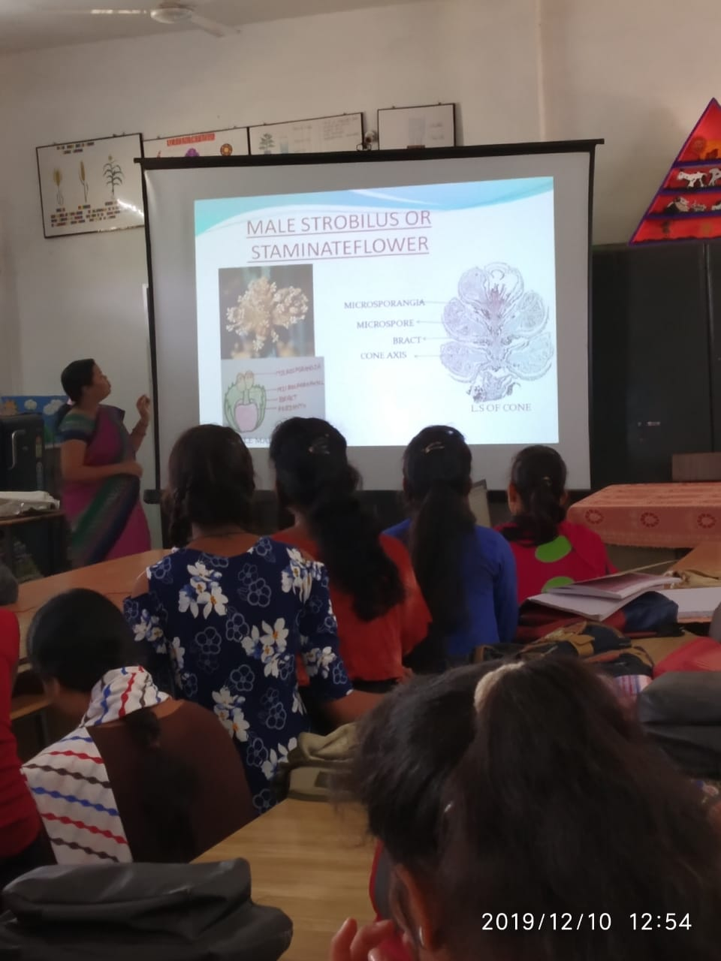
Department of Botany
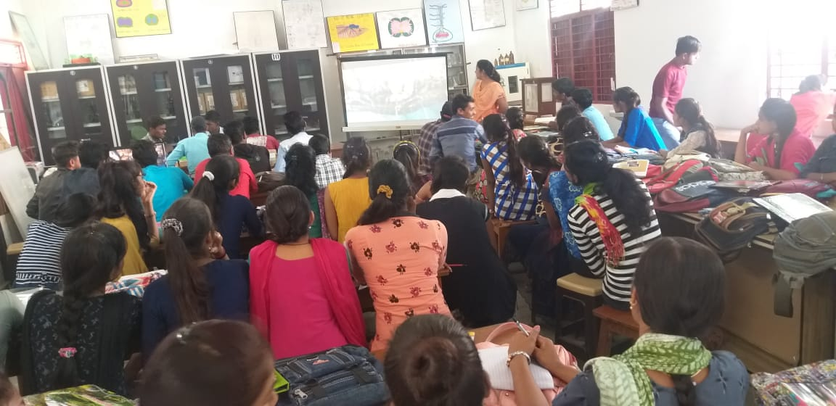
Department of Zoology
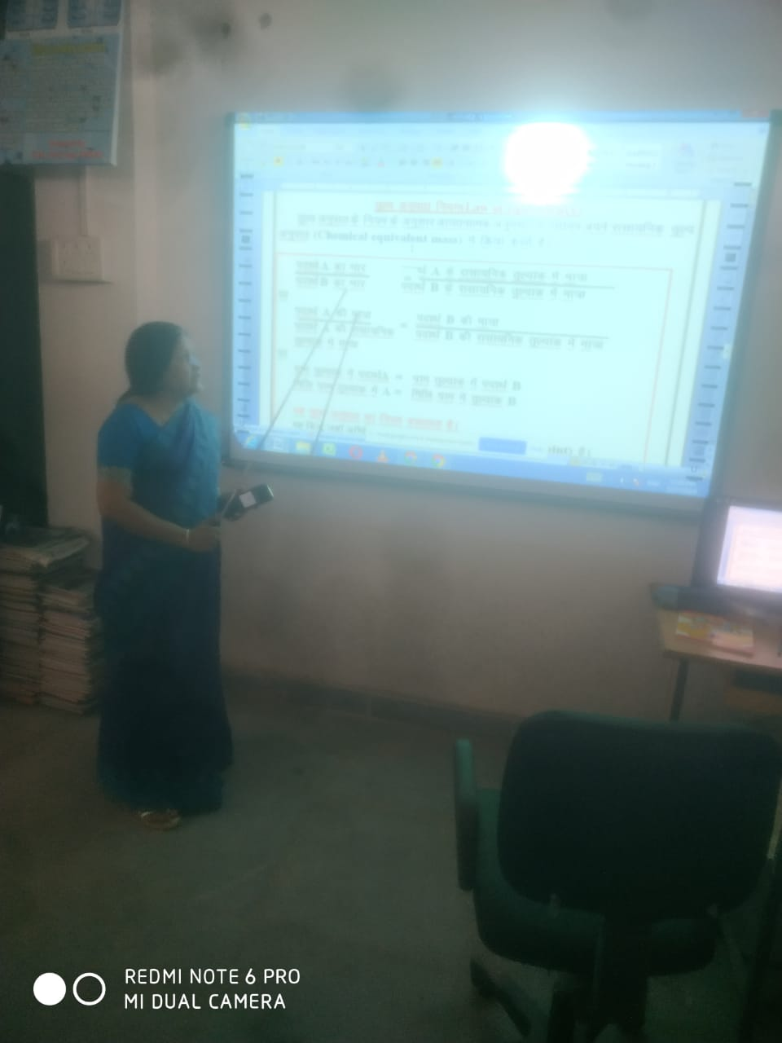
Department of Chemistry

PRESENTATION GIVEN BY THE STUDENTS THROUGH POWER POINT PRESENTATION
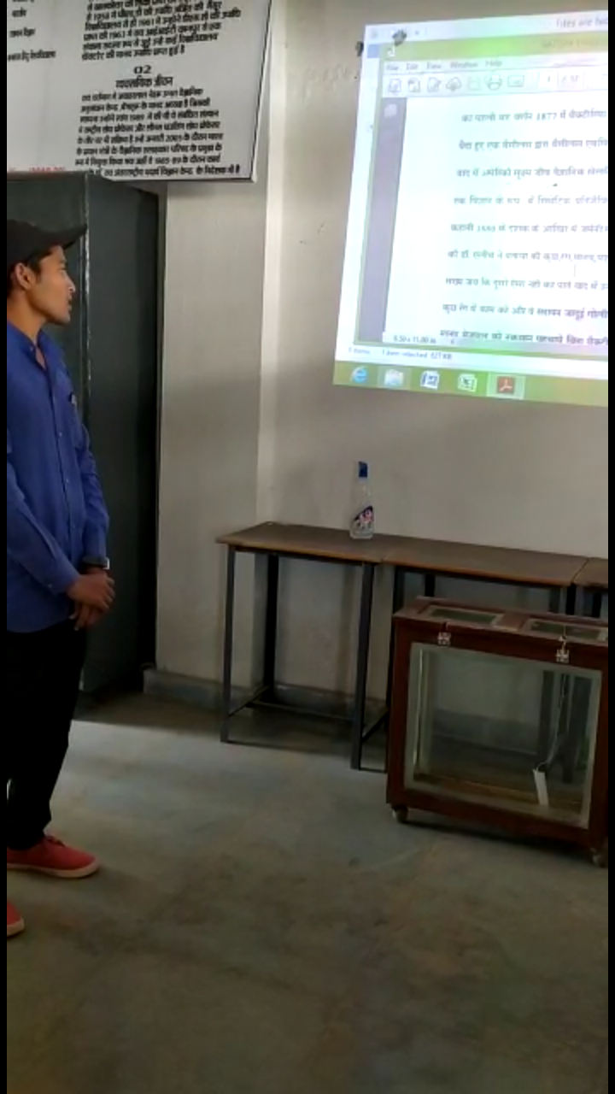

SOME OTHER ICT TOOLS USED BY THE FACULTY MEMBER OF THE COLLEGE
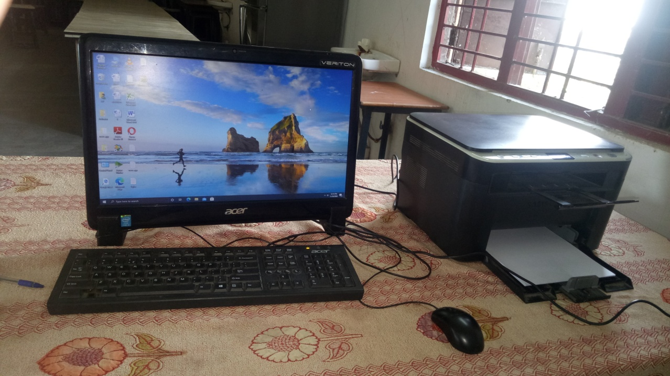
COMPUTER, PHOTOCOPIER AND PRINTER

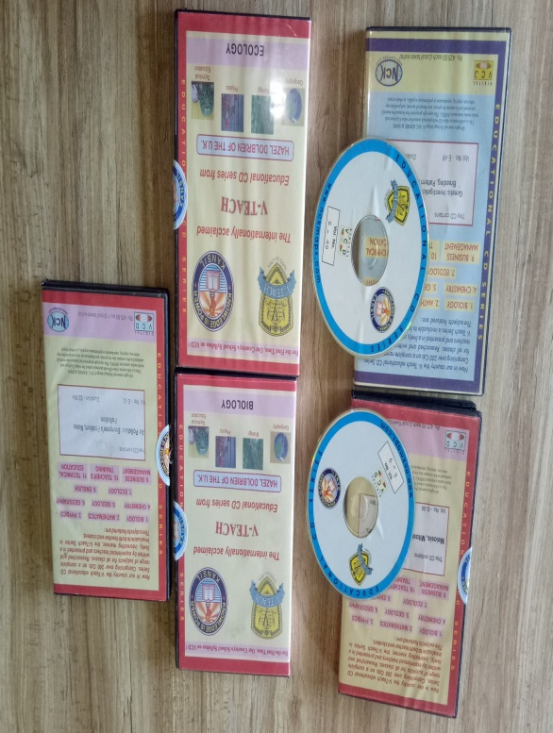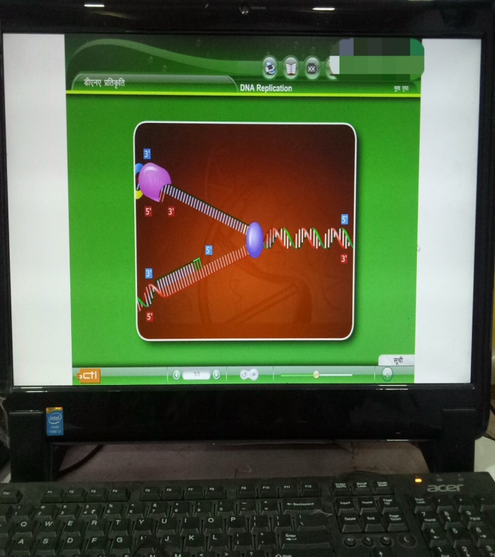
EDUCATIONAL CD EDUCATIONAL VEDIO

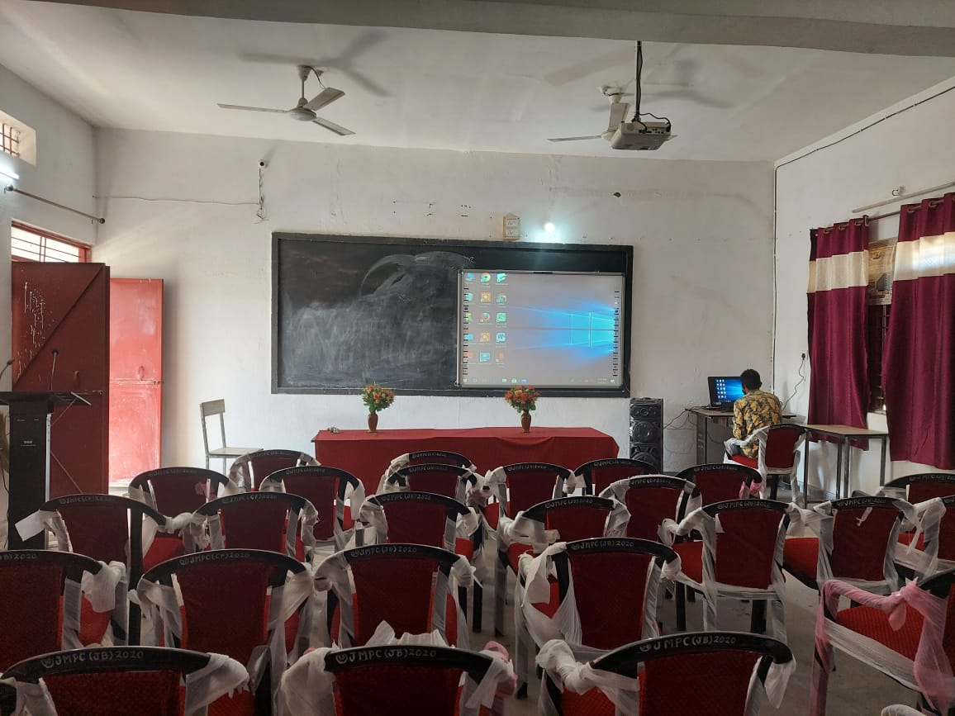
Smart Classroom

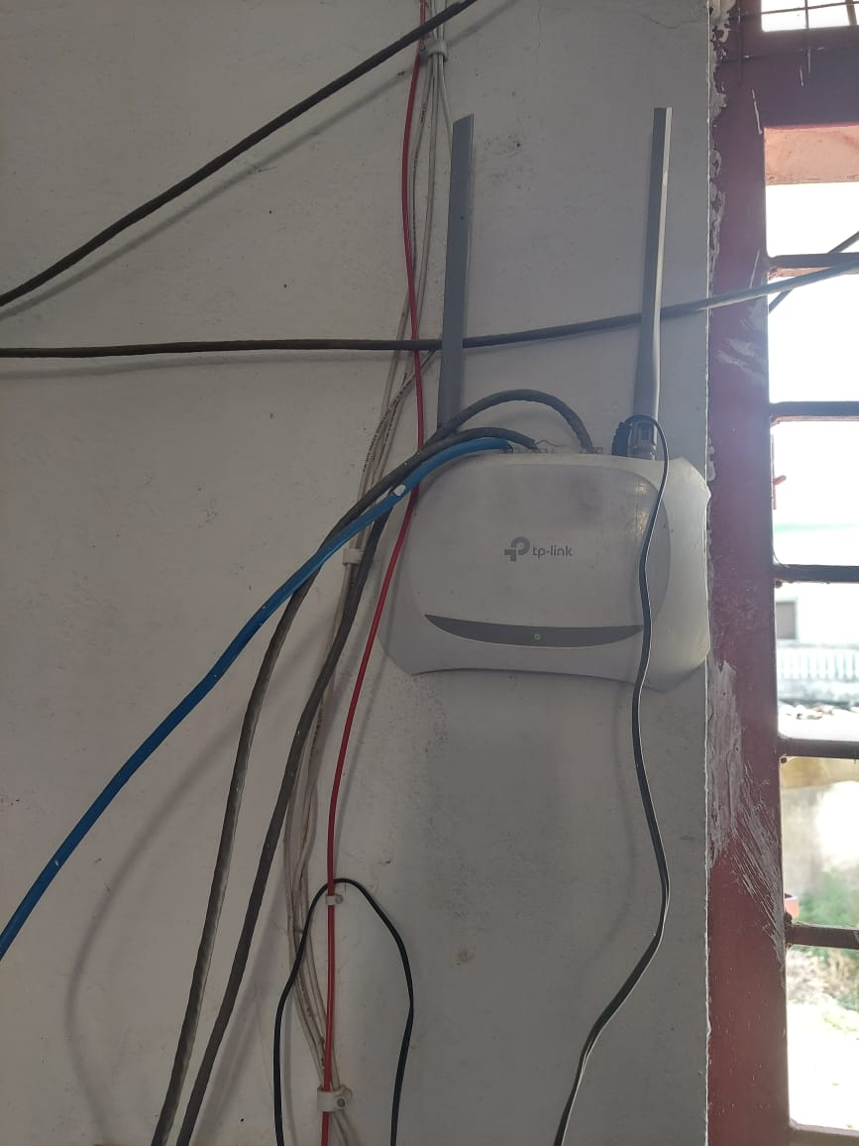
Wi-Fi Facility

